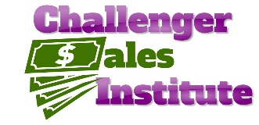

**2024 Tri-State Challenge**

**Awards Summary**

**October 8-9, 2024**

**Speed Sell Placings**

1st Laurel Brown – University of Tampa

2nd Valen Brown – Stetson University

3rd David Dishaw – Oklahoma State University

4th Dillon Carter – Stetson University

**Role Play Placings**

1st David Dishaw – Oklahoma State University

2nd Maci English – University of Central Oklahoma

3rd Alllison Rook – Oklahoma State University

4th Kevin Ha – University of Texas at Arlington

Presented by

